**ADHOC ANALYSIS INSIGHTS**

#### **CALL HANDLING EFFICIENCY ANALYSIS**

BUSINESS CASE:

How efficient is the nypd in handling calls from arrival to closure?

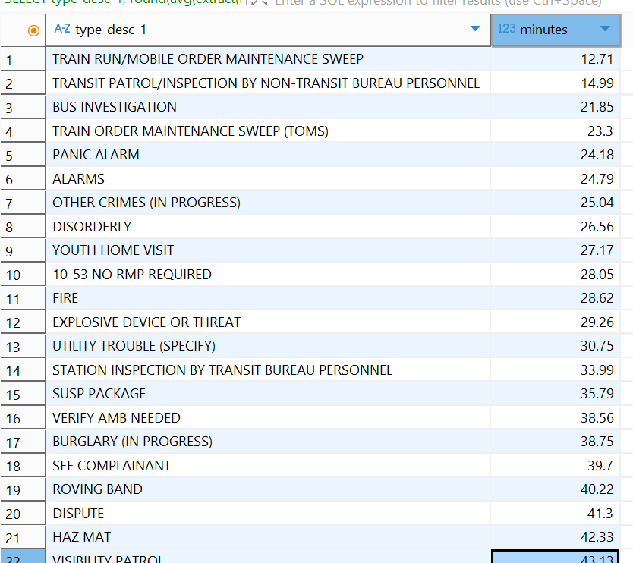

* **Fastest resolutions:** Transit-related maintenance calls (≈13–23 mins).
* **Moderate times:** Common alarms & disorderly incidents (24–30 mins).
* **Longest delays:** Serious crimes like **assaults & robberies** (70–86 mins) and officer assist (109 mins).
* Indicates **operational strain in handling high-priority incidents** compared to routine calls.

#### **UNUSUAL DELAY DETECTING**

BUSINESS CASE:

Some incidents have abnormally long durations. Nypd wants to identify potential outliers that may require investigation.

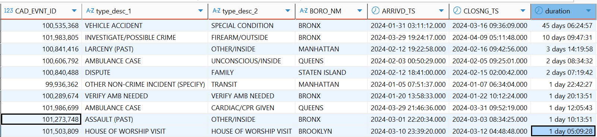

* **Outliers found:** One vehicle accident case in the Bronx stayed open for **45+ days**.
* Several seriouscases (firearm, larceny, ambulance, assault) remained unresolved for **2–10+ days**.
* Such prolonged durations may point to **system inefficiencies, ongoing investigations, or data quality issues** that require follow-up.

#### **END-TO-END RESPONSE LAG AUDIT**

BUSINESS CASE:

Measure overall system latency from when a call was added to when it was closed.

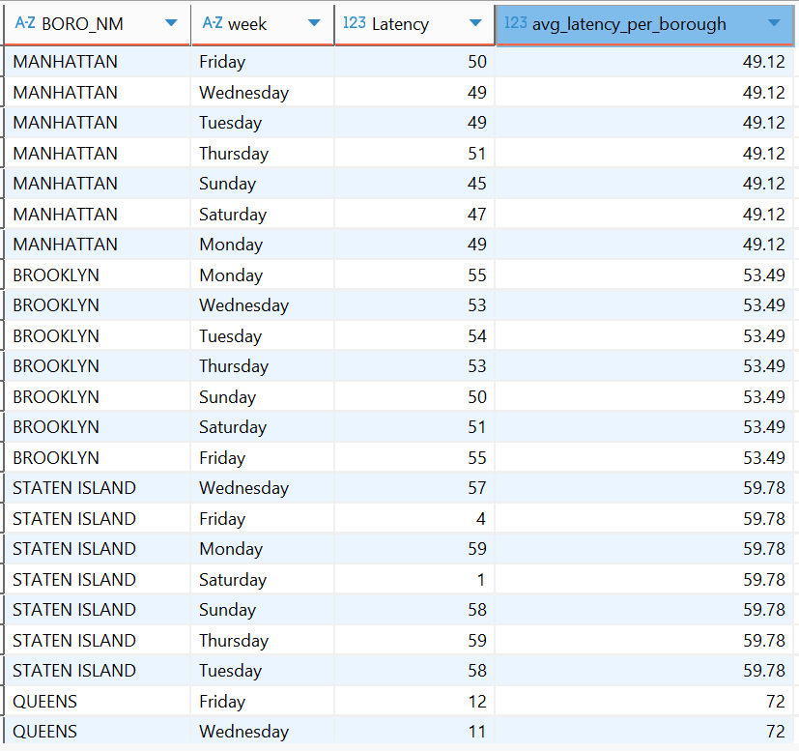

* **Bronx** has the **slowest average latency (~85 mins)**, followed by **Queens (~72 mins)**.
* **Manhattan (~49 mins)** and **Brooklyn (~53 mins)** are faster, while **Staten Island (~60 mins)** sits in the middle.
* **Null borough entries** (unmapped records, ~118 mins)

Has slowest Latency which is reasonable because of unknow borough.

* Overall, borough response times show **consistent weekly patterns**, but Bronx and Queens are lagging behind.

#### **DISPATCH DELAY BUCKETS**

BUSINESS CASE:

Classify response delays for dispatchers.

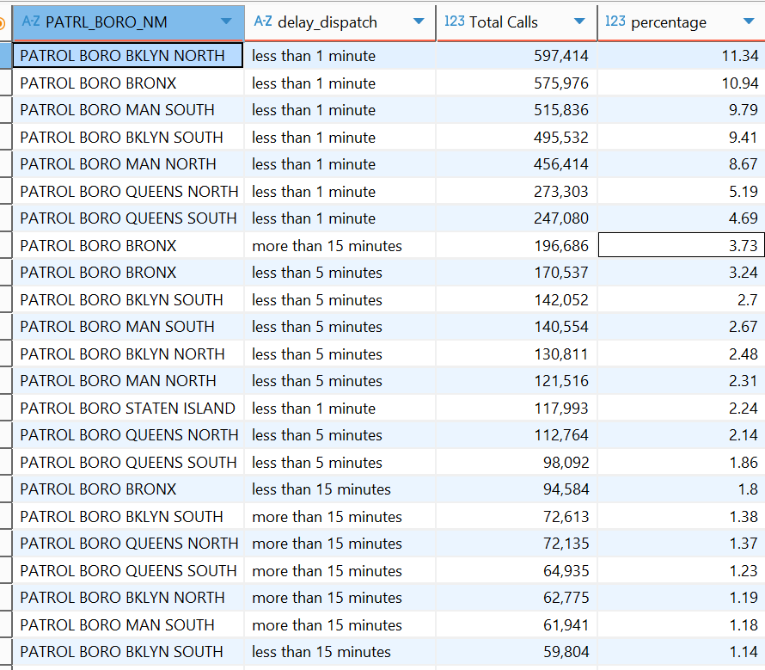

* Majority of calls are dispatched **in under 1 minute** across boroughs (Brooklyn North, Bronx, Manhattan South leading).
* A smaller but notable share (~3–4%) of Bronx calls face **15+ minute delays**, showing borough-specific lag.
* Staten Island generally has **fewer delays**, while Bronx and Queens stand out for slower dispatch cases.

#### **CRIME IN PROGRESS — PERFORMANCE REVIEW**

BUSINESS CASE:

Are CIP (crime in progress) calls handled faster?

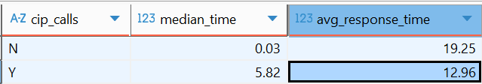

* **Median response times** are almost instant for non-CIP calls (0.03 mins) vs ~6 mins for CIP calls.
* However, **average response** is actually **faster for CIP (13 mins)** than non-CIP (19 mins), showing dispatch prioritization.
* CIP cases get **higher priority**, but variability suggests a few long delays pull up the averages.

#### **INCIDENT VOLUME DEVIATION DETECTION**

BUSINESS CASE:

Spot precincts with abnormal changes in call volume.

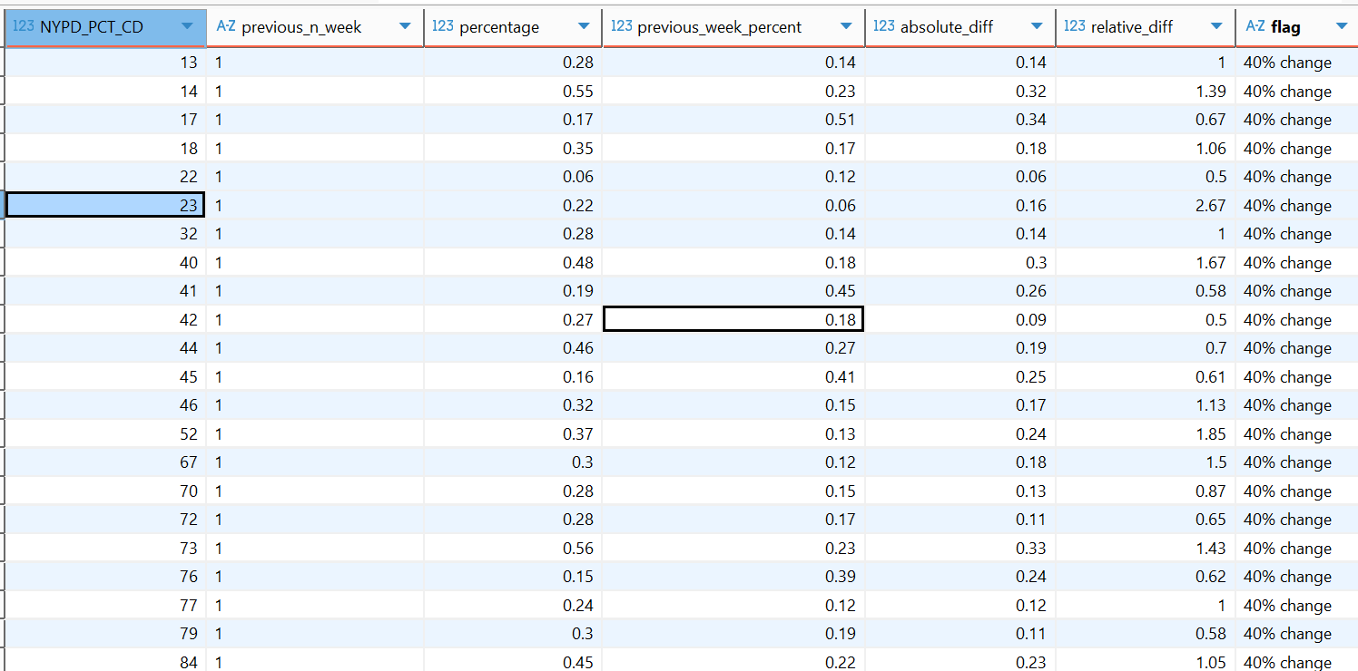

* Across the past 6 weeks, **multiple precincts showed >40% shifts in weekly call volumes**, but all flagged deviations were concentrated in the **final week of September**.
* This clustering suggests either a **genuine surge/drop in incidents citywide during that week** or a **data anomaly/reporting lag** (e.g., delayed entries or cutoff in records).
* Because deviations didn’t occur earlier, this pattern likely reflects a **system-wide effect rather than isolated precinct behavior**.

#### **TOP CALL TYPES BY GEOGRAPHIC SPREAD**

BUSINESS CASE:

Which incident types occur across the widest area?

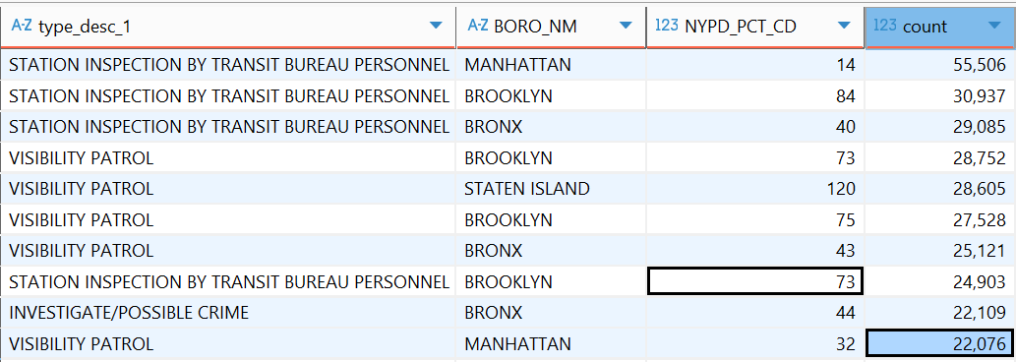

* **Station Inspections** and **Visibility Patrols** dominate across precincts and boroughs, making them the most geographically spread call types.
* These two categories appear consistently in **Manhattan, Brooklyn, Bronx, and Staten Island**, showing they’re **citywide operational priorities**.
* Other categories like **Investigate/Possible Crime** also show presence across boroughs, but at relatively lower scale.

#### **ANALYZING CALL TYPES BY DAY VS. NIGHT ACTIVITY**

BUSINESS CASE :

Which radio codes occur most frequently at night vs during the day? 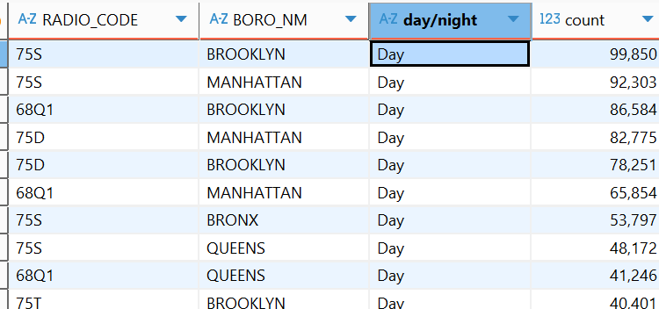

* **Night:** Codes **75D (Disorder)** & **68Q1 (Transit)** dominate in **Brooklyn/Manhattan**, each **90K+ calls**.
* **Day:** Code **75S (Suspicious activity)** leads in **Brooklyn/Manhattan**, with **~100K+ calls**; transit codes also strong in **Queens**.
* **Trend:** Nights = **urban hotspots** (Brooklyn, Manhattan). Days = **wider spread** into **Queens/Bronx** with more **transit-related calls**.

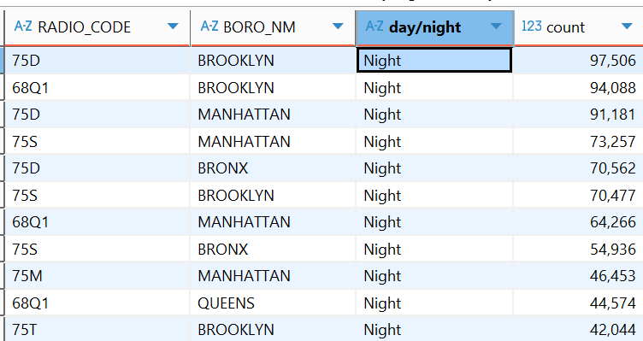

**DESCRITIVE ANALYSIS INSIGHT’S**

(Sample output screenshots)

1. TOTAL NUMBER OF CALLS (OVERALL + PER QUARTER)

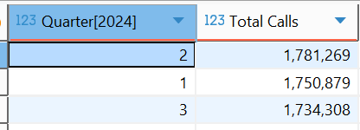

1. CALLS BY TYPE CATEGORY TOP 10

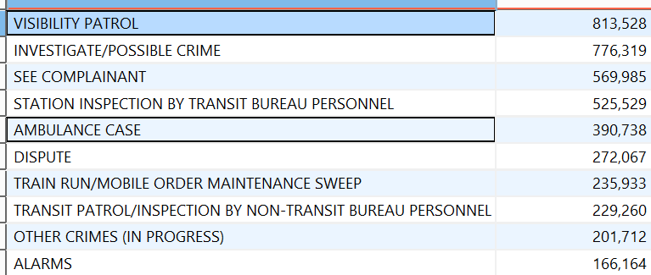

1. CALLS PER DAY OF WEEK

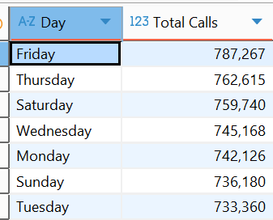

1. WHICH BOROUGH HAS THE HIGHEST VOLUME OF SERIOUS INCIDENTS? 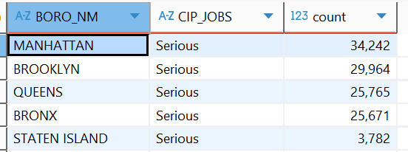
2. GROWTH/DECLINE IN CALLS ACROSS MONTHS (JAN–SEP 2024)

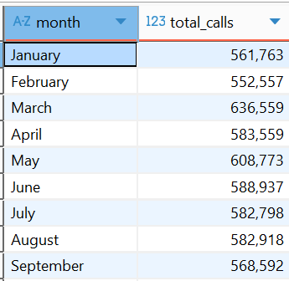

1. % OF CALLS FLAGGED AS CRIME IN PROGRESS (CIP)

